Arduino Auto-Irrigation System

**I. INTRODUCTION**

In this fast-paced world of rapid technological advancements and breakthroughs happening every day, we, human beings, prefer everything automated and easy. From cultivating crops to attempting to conquer space, we rely on technology all because of its past conquests, contributing to make our life easier.

Understanding the need and application of technology in today’s world our group has come up with a concept contributing to exonerate the farmers and cultivators from the usual burden they face in their area of work: agriculture, due to irrigation. Irrigation, in simple words, is defined as an artificial application of water into a land or soil. The proper cultivation of crops demands an adequate supply of water: water is a very precious resource when it comes to cultivation. It assists in keeping the plants always moisturized and catalyzes the proper supply of nutrients throughout the plant. However, irrigation is a very enervating task, as it requires us to either wait for the natural method of water supply: rain or build a passage from the river to the field. However, this method of irrigation risks the vitality of the crops and the soil itself due to the high possibility of the land being flooded, the soil being eroded, and the water being wasted. Hence, to make irrigation a simpler, convenient, friendly, fun concept, we have made an “AUTOMATIC IRRIGATION SYSTEM”: a model for controlling irrigation facilities to help millions of people.

Nepal, a country with huge agricultural potential, lacks the technical prowess to harness this prospect. More precisely, we think it lacks “The automatic side of agriculture”. We started this project with the intention to make a system that automatically manages the irrigation side of things; hence the name, “Auto-Irrigation System”. We’ve sequestered this project into various parts and each part has its own purpose to make this project an ideal one. But we all know that this project is far from its potential. We’ve set out on a journey to constantly improve this project as we go along and we hope that it could at least reduce, if not efface the problem of manual work in the agricultural industry.

**II. Problem Statement**

The economy of many countries depends on agriculture. To achieve the best quality from this research, it is important to focus on some vital characteristics such as the appropriate amount of electricity as well as water supply and a suitable schedule for irrigation of crops. Farmers are facing problems in meeting these standards, especially those living under the poverty line in DEVELOPING NATIONS.

In the context of Nepal, despite having a 69% labor force, agriculture merely contributes to about 30% of the country’s overall GDP. One of the reasons for this drastic difference in statistics is because of the farmers’ inability to attend to all their crops in time, which leads to the decline in harvest rates on a large scale: the unattended crops tend to die out because of lack of supply of nutrients. When this happens, most of the farmers opt for industrial fertilizers, thereby temporarily increasing harvest rate and permanently decreasing the quality of the soil: by increasing its acidity.

This project looks into developing an automated irrigation system that could be controlled and monitored through a mobile application. This system shall work to minimize the number of workers in a crop field, control and save water and electricity, increase agricultural yield using small quantities of water, minimize manual intervention in watering operations with increasing watering speed, and preserve plants from fungi. All these features contribute to making this system a technological advancement in the world of manual irrigation, which is both time and effort consuming.

**III. Items Used:**

The following items were used in building this project: Arduino UNO, 16x2 LCD, Breadboard, Soil moisture sensor, One channel 5V Relay, Ultrasonic sensor, Real time clock chip, Ethernet shield, Water level sensor, Jumper cables, LED, Buzzer, and Resistor.

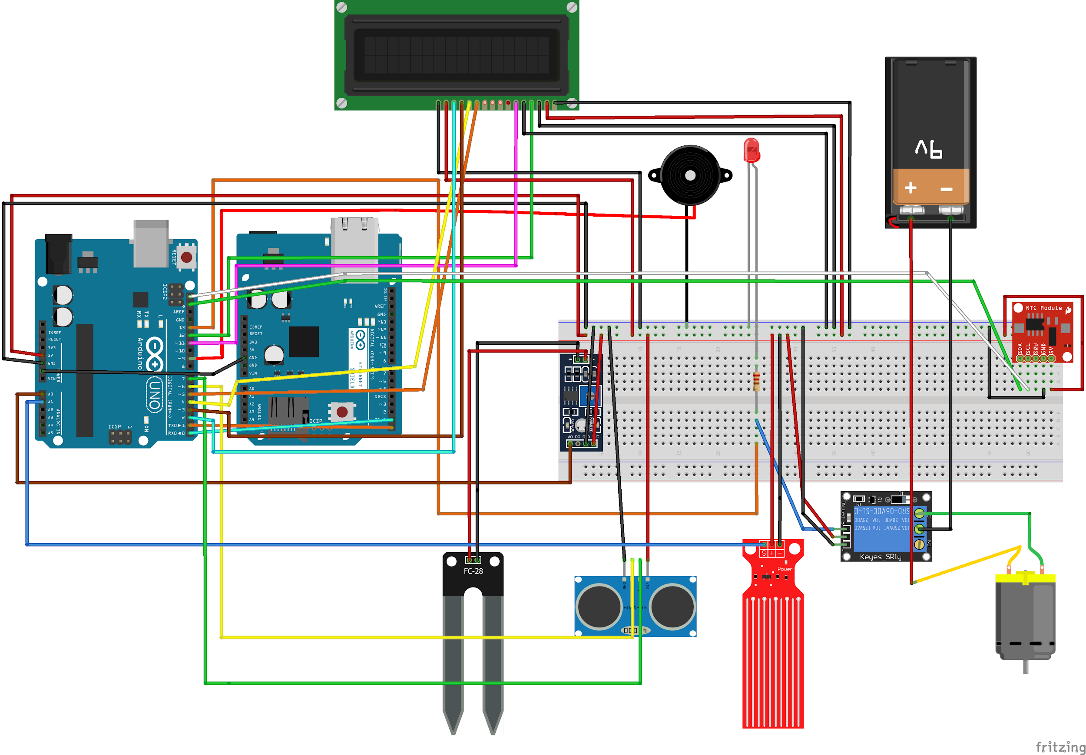

**IV. Basic working:**

The Arduino reads the status of the soil: dry, moist, soggy using the soil moisture sensor. If the soil is DRY, it performs the following operations:

1) Checks for the availability of water using the water level sensor.

2) If the water is available, the Pump is turned ON and is automatically turned OFF when sufficient water is supplied. A relay driver circuit drives the pump.

3) If the Water is unavailable, the buzzer buzzes to notify you with a buzz.

The status of soil and the status of the pump is displayed on the LCD screen, sending the data to the app, so that the user can monitor the status of the system through the app from anywhere in the world.

**V. Benefits:**

1. Easy to implement: The materials required for this project are easy to install, easy to replace, and easy to connect thereby contributing to implement a successful project

2. Open source: Use of an open-source controller due to which the used hardware comes at a reasonable price with a free development software.

3. Modifiability: The project can run in any type of soil and environment with simple and easy modifications to fit the requirements.

4. Communication: Use of internet and a real-time clock to send accurate data to the web server; data including starting and stopping time of the water pump, volume of water used can be seen on the app, making the system able to be monitored easily from everywhere.

5. Automatic: Automation eliminates the manual operation of opening or closing valves.

6. Energy Saving: Irrigation process starts and stops exactly when required, thus optimizing energy requirements.

7. Cost: While it may seem a tad expensive in the initial stages of buying this product for the farmers in the rural areas, in the long run, it pays off by outweighing the money they used to use for irrigating.

8. Effective plant growth: Minimizes water waste and improves plant growth as the plants get the required amount of water in fixed intervals.

9. Saves time

The benefits are totally applicable in the context of our country as the mentioned uses go hand in hand in solving the problems we face.

**VI. Some drawbacks that were found:**

1. Requires electricity.

2. Initially it might be expensive:

Buying all the technical stuff may seem expensive initially, but if we really look at it in the long-term, then it is cost-effective. You may ask how? So, after installing this system, there is no need for any manpower to operate as the whole system is automatic. The time that farmers used to water the plants is conserved and now can be utilized in other productive works. Thus, we’ll be able to save energy, time and manpower and therefore in the long-term, we’ll be saving money.

**VII. Further improvements:**

Following concepts can be applied to improve the entire system and take it to the next level:

1. Use of a rain sensor that checks the presence of rainwater when the soil is dry to stop interfering with natural irrigation to prevent water loss.

2. Another addition could be use of a temperature sensor and a light sensor. If the temperature is high and the percentage of light is high, then the system will not work because it is not the right time for the irrigation process because the water will easily evaporate during that time. So, the system will only turn on in conditions when there is low light (like during night).

3. If the water level is low in the tank, then the system will shut down automatically and send SMS to the user, by using a water level sensor.

4. The problem of electricity can be countered by powering the system with solar power.

5. We can further enhance the system by figuring out different conditions required for proper growth of different types of plants as all plants are different. We can research more about this with the help of agriculture specialists.